

Viper Co.

# Sprint 1 – Deliverables

**SCRUM Team Biography & Team Member Roles**

**Team Name:** Viper Co.

**SCRUM Master:**

**Email:**

|  |  |  |
| --- | --- | --- |
| **Group Member** | **Skills** | **Roles** |
|  | **Strengths:** SQL, Presenting, Problem Solving.  **Weaknesses:** Organization | **Primary:** Business Analyst **Secondary:** Database Expert |
|  | **Strengths:** Presentation development, presenting, Analytics  **Weaknesses:** Programming | **Primary:** User Experience Expert **Secondary:** Client Liaison |
|  | **Strengths: P**rogramming, analytical skills  **Weaknesses:** business writing | **Primary:** Developer **Secondary:** Scrum master |
|  | **Strengths:** Organization, communication skills, analytical skills, user experience expert  **Weaknesses:** Programming, technical development | **Primary:** Client Liaison **Secondary:** Business Analyst |
|  | **Strengths:** Database  **Weaknesses:** Presentation Development | **Primary:** Database expert **Secondary:** User Experience Expert |

**Team Strengths**: Programming: SQL, C#, analytical skills, problem solving skills, communication skills, organizational skills

**Team Weaknesses:** We have a diverse set of skills which for the most part is good, but it may make it more difficult to consolidate knowledge on a particular problem if the problem is outside of our expertise area. Decision making.

## Viper Co. Contract & Code of Conduct:

### Description

Viper Co. provides superior problem-solving services and delivers the highest quality of products to clients. Our team values commitment, transparency, fairness and consistency, and lastly accountability. Every member of our team strictly follows a set of rules that are elaborated below in the code of conduct.

Viper Co. comprises five members who each has their own designated role. Business analyst, database developer, user experience expert, and client liaison all collaborate closely to navigate every single project. Our operating framework uses SCRUM, a method many professionals use to address complex adaptive problems while productively delivering products of the highest possible values.

### Code of Conduct

We trust our team members to make good decisions for the company as rules and guidelines are established and followed. As a team we will:

A. Commitments:

1. Respect each other

2. Operates in a proactive manner

3. Focus on what is best for the project through to completion

B. Participation:

1. Be honest and open during meetings

2. Encourage a diversity of opinions in discussions

3. When things go wrong, the team will discuss how to improve instead of placing blames on individuals

C. Communication:

1. Use the established group chat to its full potential

2. Be clear and to the point to keep discussions on track

3. Practice effective listening skills and use any visual tools to facilitate discussion

D. Decision Making:

1. Discuss all criteria before finalizing a decision

2. Get input from the entire team before a decision is made

E. Handling Conflict:

1. Understand the situation of each party involved before making assumptions

2. Listen openly to all members on the team and speak in a non-attacking manner

3. Seek to find common ground for agreement

4. If the issue is unable to be resolved within the team, we will advise an authority (Professor) accordingly

F. Meeting Guidelines:

1. Meetings will be held every Tuesday/Thursday after 4:45p.m.

2. Team members will come to the meetings

3. If a member cannot attend a meeting, he/she will follow up the meeting agendas in the team group chat

By signing, I’m agreeing to the Terms and Conditions of Viper Co. Contract & Code of Conduct after reading carefully:

## System Vision Document:

### Problem Description and Solution

“The Full Cycle” addresses several problems that all relate to one another. One problem is that some community members have an excess amount of food. Because they do not need this food, they will not use it and it will go to waste. Another problem addressed is that other community members who are in need of food. The volunteer organization connects these two groups, allowing food that would otherwise be wasted to be given to those who don’t have enough to eat. To build upon this solution, our system aims to facilitate the connection between these two groups. It also aims to create efficiency for volunteers running the process. Through tracking donors, donations, volunteers, and recipients, our system will help organize the connections and data that need to be tracked in order for the operation to be successful. The system will also aim to create efficiency in the routing of food collection and disbursement.

### System Capabilities

a. Donor Capabilities:

* + - 1. Ability to create account/log in
      2. Ability to log their donations
      3. Ability to retract their donationif it has not been picked up yet
      4. Ability to track what they have donated

b. Recipient Capabilities:

* + - 1. Ability to create account/log in
      2. Ability to make a request for a donation
      3. Ability to view the status of the request

c. Volunteer Capabilities:

* + - 1. Ability to create account/log in
      2. Ability to track the hours they have worked
      3. Ability to update inconsistent data in the system (such as reconciling inventory with a physical count), add new stock, or delete inventory items
      4. Ability to view donations and food orders
      5. Manage tracking of missed deliveries

d. Automation Capabilities:

Automatic routing of food collection and disbursement

### Business Benefits

This system adds the benefit of increased organization. It allows data to easily be tracked. This makes it easier for volunteers to find how much time they have worked, for recipients to easily find food that fills their needs, and for donors to easily make donations. Overall, the system adds efficiency. It creates a scenario where this data is automatically tracked. Not having the system, or using a paper system, allows for an increased chance of lost information. By automating specific tasks, the system opens up free time for those who interact with the volunteer organization.

### Elevator Pitch

Our system will facilitate the connection between donors, volunteers, and recipients. It will allow for increased ease in tracking donation information. It will also allow volunteers, donors, and recipients to interact with the organization with more efficiency.

# Backlog Items

|  |  |
| --- | --- |
| **Must Have:** | |
| User Story: | Estimate: |
| As a volunteer I want to create an account to view administrative functions. | 1 |
| As a volunteer I want to view/add/update/delete inventory to ensure the current data is accurate. | 2 |
| As an admin I want to view all user accounts and their history of donations to maintain a record of activities. | 3 |
| As a volunteer I want to view the recipient of a donation, the date it occurred, and the items that were given to document all transactions that occur. | 5 |
| As a volunteer I want to view any missed deliveries to ensure all recipients receive their donations. | 8 |
| As a volunteer I want to view my hours worked so I can understand my output. | 3 |
| As a donor I want to create an account to view donor functions. | 1 |
| As a donor I want to add donations to the database to maintain accurate inventory counts. | 2 |
| As a donor I want to view my previous donations so I can be confident that the information is accurate. | 3 |
| As a recipient I want to create an account to view recipient functions. | 1 |
| As a recipient I want to request a donation so I can receive assistance. | 2 |
| As a recipient I want to view my donation requests, so I know if it has been processed. | 3 |
| As a user I want to view a list of donors, volunteers, and recipients to know who the key players are. | 1 |
| **Should Have:** | |
| User Story: | Estimate: |
| As a donor I want to delete/edit a donation if it has not been picked up yet to make any necessary changes to the order. | 5 |
| **Could Have:** | |
|  |  |
| User Story: | Estimate: |
| As a volunteer I want to make postings for food items the organization currently needs so recipients can receive their requests | 8 |
| As a donor I want to view current postings to donate any requested items. | 8 |

# Sprint 2

|  |  |
| --- | --- |
| **Must Have:** | |
| User Story: | Estimate: |
| As a volunteer I want to create an account to view administrative functions. | 1 |
| As a donor I want to create an account to view donor functions. | 1 |
| As a recipient I want to create an account to view recipient functions. | 1 |
| As a volunteer I want to view/add/update/delete inventory to ensure the current data is accurate. | 2 |
| As an admin I want to view all user accounts and their history of donations to maintain a record of activities. | 3 |
| As a volunteer I want to view the recipient of a donation, the date it occurred, and the items that were given to document all transactions that occur. | 5 |
| As a volunteer I want to view any missed deliveries to ensure all recipients receive their donations. | 8 |
| As a volunteer I want to view my hours worked so I can understand my output. | 3 |
| As a donor I want to add donations to the database to maintain accurate inventory counts. | 2 |
| As a donor I want to view my previous donations so I can be confident that the information is accurate. | 3 |
| As a recipient I want to request a donation so I can receive assistance. | 2 |
| As a recipient I want to view my donation requests, so I know if it has been processed. | 3 |
| As a user I want to view a list of donors, volunteers, and recipients to know who the key players are. | 1 |
| **Should Have:** | |
| User Story: | Estimate: |
| As a donor I want to delete/edit a donation if it has not been picked up yet to make any necessary changes to the order. | 5 |
| **Could Have:** | |
| User Story: | Estimate: |
| As a volunteer I want to make postings for food items the organization currently needs so recipients can receive their requests. | 8 |
| As a donor I want to view current postings to donate any requested items. | 8 |

## Sprint 2 - Task List

|  |  |  |
| --- | --- | --- |
| **As a volunteer I want to create an account to view administrative functions.** | | |
| **Task** | **Estimate** | **Team Member** |
| Database design | 2 hrs. | Reese |
| Project documentation | 1 hr. | Judy |
| Project analysis | 1 hr. | Corey/Akisumi |
| GUI design | 1 hr. | Quinton/others |
| Build code | 1 hr. | Quinton |
| **As a donor I want to create an account to view donor functions.** | | |
| **Task** | **Estimate** | **Team Member** |
| Database design | 2 hrs. | Reese |
| Project documentation | 1 hr. | Judy |
| Project analysis | 1 hr. | Corey/Akisumi |
| GUI design | 1 hr. | Quinton/others |
| Build code | 1 hr. | Quinton |
| **As a recipient I want to create an account to view recipient functions.** | | |
| **Task** | **Estimate** | **Team Member** |
| Database design | 2 hrs. | Reese |
| Project documentation | 1 hr. | Judy |
| Project analysis | 1 hr. | Corey/Akisumi |
| GUI design | 1 hr. | Quinton/others |
| Build code | 1 hr. | Quinton |

Acceptance Criteria - Donor User Story

|  |  |
| --- | --- |
| **Acceptance Criteria** | **Met?** |
| Donor created in the database | Met |
| Donor cannot create account with duplicate username | Met |

Acceptance Criteria - Recipient User Story

|  |  |
| --- | --- |
| **Acceptance Criteria** | **Met?** |
| Recipient created in the database | Met |
| Recipient cannot create account with duplicate username | Met |

Acceptance Criteria - Volunteer User Story

|  |  |
| --- | --- |
| **Acceptance Criteria** | **Met?** |
| Volunteer created in the database | Met |
| Volunteer cannot create account with duplicate username | Met |
| Volunteers cannot create a volunteer account without validation key | Met |

## Sprint 2 – Design

### Database Design

Figure 1. Entity diagram for primary database (last updated Sprint 2)

### Activity Diagram for Account Creation

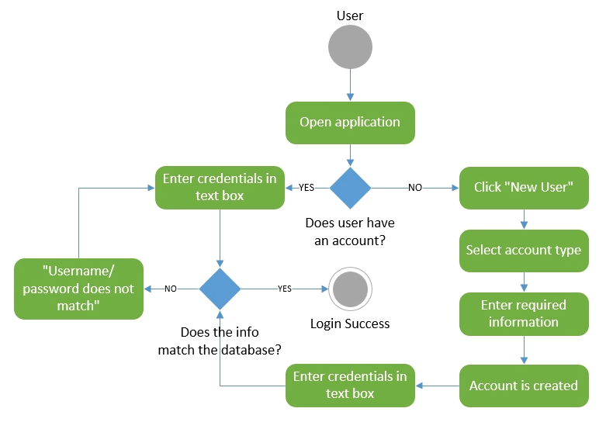

## Sprint Retrospective

### Start Doing

* Keep team members updated on any changes that have been made

### Stop Doing

* Jumping into sprints unprepared (Focus more on planning)

### Continue Doing

* Allocate tasks to team member’s specific strengths
* Communication between database designer and programmer

# Sprint 3

## Backlog

|  |  |
| --- | --- |
| **Must Have:** | |
| User Story: | Estimate: |
| As a volunteer I want to create an account to view administrative functions. | 1 |
| As a donor I want to create an account to view donor functions. | 1 |
| As a recipient I want to create an account to view recipient functions. | 1 |
| As a donor I want to add donations to the database to maintain accurate inventory counts. | 2 |
| As a user I want to login to the system to access functions | 1 |
| As a donor I want to view my previous donations so I can be confident that the information is accurate. | 2 |
| As a volunteer I want to view/add/update/delete inventory to ensure the current data is accurate. | 3 |
| As an admin I want to view all user accounts and their history of donations to maintain a record of activities. | 3 |
| As a volunteer I want to view the recipient of a donation, the date it occurred, and the items that were given to document all transactions that occur. | 5 |
| As a volunteer I want to view any missed deliveries to ensure all recipients receive their donations. | 8 |
| As a volunteer I want to view my hours worked so I can understand my output. | 3 |
| As a recipient I want to request a donation so I can receive assistance. | 2 |
| As a recipient I want to view my donation requests, so I know if it has been processed. | 3 |
| As a user I want to view a list of donors, volunteers, and recipients to know who the key players are. | 1 |
| **Should Have:** | |
| User Story: | Estimate: |
| As a donor I want to delete/edit a donation if it has not been picked up yet to make any necessary changes to the order. | 5 |
| **Could Have:** | |
| User Story: | Estimate: |
| As a volunteer I want to make postings for food items the organization currently needs so recipients can receive their requests. | 8 |
| As a donor I want to view current postings to donate any requested items. | 8 |

## Task List and Acceptance Criteria

**As a donor I want to add donations to the database to maintain accurate inventory counts.**

|  |  |  |
| --- | --- | --- |
| **Task List** | | |
| **Task** | **Estimate** | **Team Member** |
| Project documentation | 1 hr. | Judy |
| Project analysis | 1 hr. | Corey/Akisumi |
| Build system in Visual Studio | 2 hrs. | Quinton/others |
| Design SQL Queries | 1 hr. | Quinton/Reese |
| **Acceptance Criteria** | | |
| **Criteria** | | **Met?** |
| Data entered is validated before being added to database | | Met |
| Entered data is stored into database | | Met |

**As a user I want to login to the system to access functions**

|  |  |  |
| --- | --- | --- |
| **Task List** | | |
| **Task** | **Estimate** | **Team Member** |
| Project documentation | 1 hr. | Judy |
| Project analysis | 1 hr. | Corey/Akisumi |
| Build system in Visual Studio | 2 hrs. | Quinton/others |
| Design SQL Queries | 1 hr. | Quinton/Reese |
| **Acceptance Criteria** | | |
| **Criteria** | | **Met?** |
| Entered username is matched with password in database | | Met |
| System redirects user to their applicable home screen (Volunteer, Donor, Recipient) | | Met |

## Design Docs

### Activity Diagrams:

Figure . Activity diagram describing adding donations

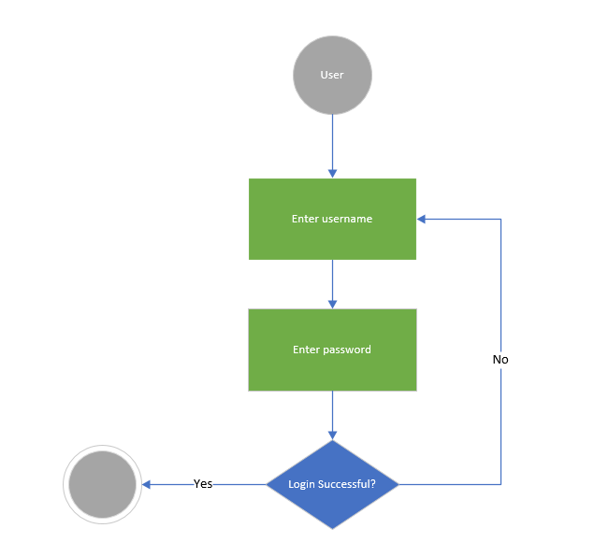

Figure . Activity diagram describing user login process

## Sprint 3 - Sprint Retrospective

### Start Doing

* Start recording task list and acceptance criteria as one table for easier replicability as the professor suggested

### Stop Doing

* Currently not applicable

### Continue Doing

* Allocate tasks to team member’s specific strengths
* Communication between database designer and programmer via text messaging
* Keep team members updated with developments in the project via GroupMe